**Acme Retail Sales**

Bryan Cameron Cromer

Data Warehousing Technology Section 1

Dr. Toland

Wednesday, December 6

**Abstract**

*To compete in the ever-growing modern economy, a company must be efficient and well informed. Acme Retail Sales is a large retail supply company who has outgrown their current order and inventory system. The company has already begun building a database, but does not want to perform trend predicting query on their database system directly. They have outgrown the capacity of their current record keeping system and need a data warehousing system to predict trends. The warehouse discussed in this paper shows how a proper data warehouse could increase a company’s efficiency by allowing them to predict trends, addressing Acme Retail Sales’ problem.*

1. **Introduction**

Acme Retail Sales is a large retail supplier company with multiple facilities. Acme sends products across the United States that are received from all over the world. They have found themselves in an inventory management crisis because they have been using paper and pen to keep track of their inventory. A need for a database has been created by their actions; furthermore, they have asked for a data warehouse to be able perform analysis without slowing down their systems.

The company’s current question for the data warehouse is: “Which state has the most orders in the fourth quarter?” The answer to this question could save the company time and money on shipping and would allow them to place trucks in the correct locations. Acme could take this information as a foundation and begin researching which facilities should house which type of products during quarter four.

This document is organized as follows. In Section 2 is an explanation of the source data and an entity relationship diagram. Section 3 discusses the marketing question, the dimensional diagram, and the report generated for the marketing question. Section 4 covers the results of the execution of the data warehouse and the report generated using the source data. Section 5 serves as the conclusion.

1. **Entity Relationship Diagram**

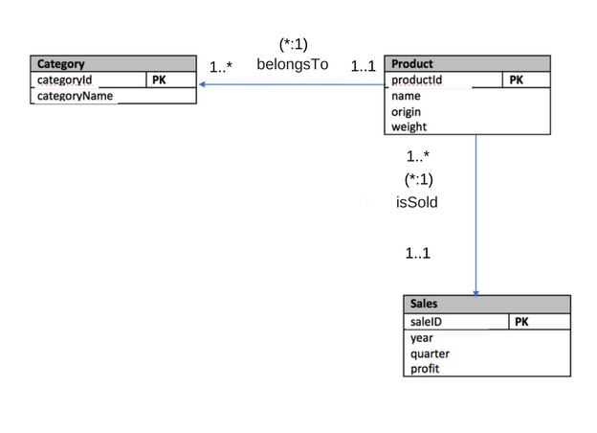

Fig. 1. Entity Relationship (ER) Diagram for Acme Retail Sales’ Source Database

There are three major tables inside the source data that Acme Retail Sales wanted to work with inside their data warehouse. Each table stores the most vital information needed for the operations of the company. There are two different relationships represented inside Figure One: a representation of a product belonging to a category and the other representing a product being sold in a sale.

1. **Dimensional Diagram**

Acme Retail Sales asked this question: “What state has the most orders during quarter four of year 2014, sorted by number of orders?”



Fig. 2. Dimensional Diagram of the Data Warehouse

Fig. 2 shows the relationships between the two dimensions (time and sales) and the fact table (states). The Time_Dim table holds the quarter the sale happened and the date of the sale. “TimeNum” acts as the table’s primary key. Sales_Dim holds the ID of the sale and the state that the good are being shipped to. Here, “SalesNum” acts as the tables primary key. States_Fact holds TimeNum and SalesNum, which is used to reference the other two tables as the report is being created.

There are two reports created from Fig. 2. Both reports contain the headers “Quarter,” “State,” and “Number of Orders.” “Number of Orders” shows how many orders went to each state during quarter four. One report will also contain “Ranking” which represents how each individual state ranks against all the other states.

1. **Data Warehouse Report Discussion**

Acme Retail Sale asked to a report from the Data Warehouse. A Rollup Report and Dense Rank report is provided below.

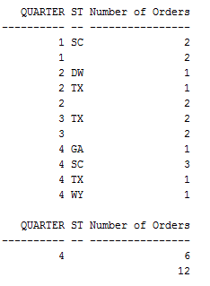

Fig. 3. ROLLUP Report (2014)

Figure 3 shows all the orders that Acme Retail Sales have generated during 2014. It also shows that during quarter four, six orders were order placed, and South Carolina had placed the most orders.

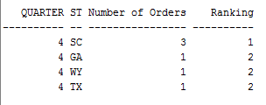

Fig. 4. Dense Rank Report (2014)

Figure 4 shows a dense rank report for quarter four of 2014. As listed, South Carolina ranked first with three orders, and all other states had only placed one order each during this time.

1. **Conclusion**

Acme Retail Sales had a need for a data warehouse to manage their increase in orders and to track trends. The implemented data warehouse loads all the data from the data source and then breaks it into three different tables to analyze the trends. This data warehouse generated two reports to show the trends of 2014.

The data warehouse could be improved by extending the existing dimension tables to include more data from the source data. Also, the reports could be created with the date to create better, more readable reports. More dimensions could be added to the data warehouse to give the engineer the ability to create different types of reports for the company.